TC-CMS-014
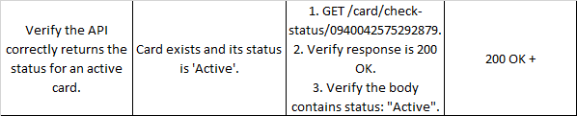
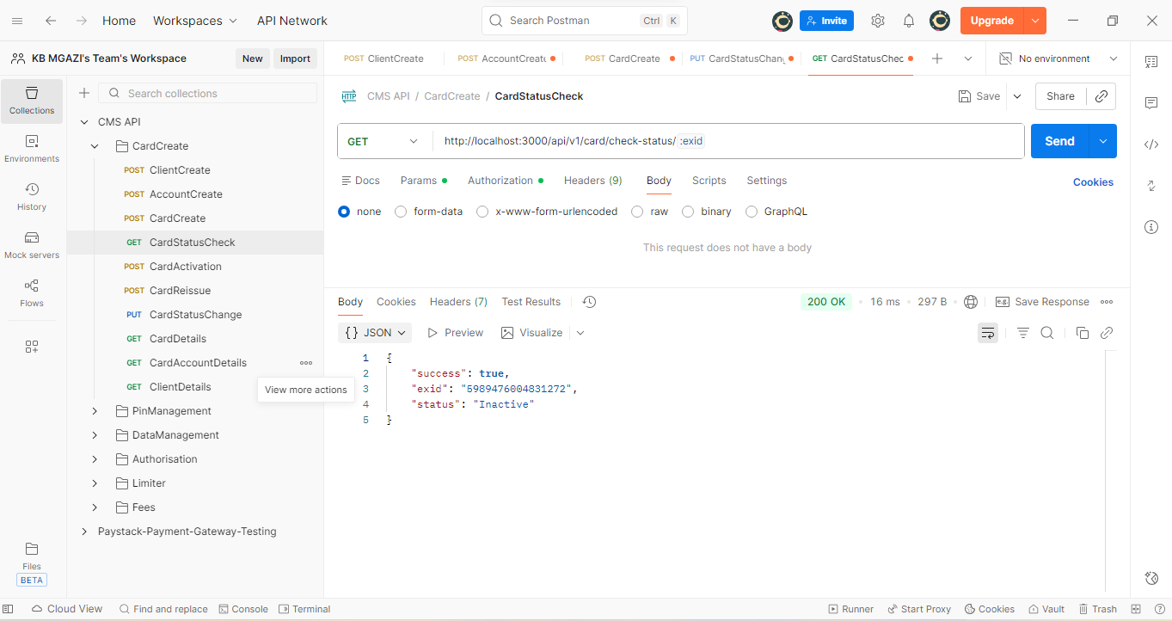
Response:
{
"success": true,
"exid": "5989476004831272",
"status": "Inactive"
}

